**Black Wooden Scalloped Floating Wall Shelves**

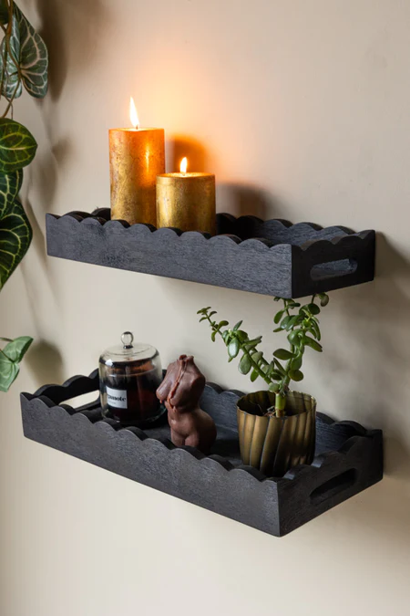The black wooden scalloped floating wall shelves bring a blend of rustic charm and modern design to any space. Featuring intricate scalloped edges, these shelves not only provide functional storage but also serve as decorative elements. Perfect for displaying candles, small plants, or collectibles, their dark finish adds contrast and warmth to a light-coloured wall. Ideal for creating cozy and elegant vibes, these shelves effortlessly complement various interior styles, from farmhouse to contemporary.